Dancing in Heaven With Jesus
7.2.26

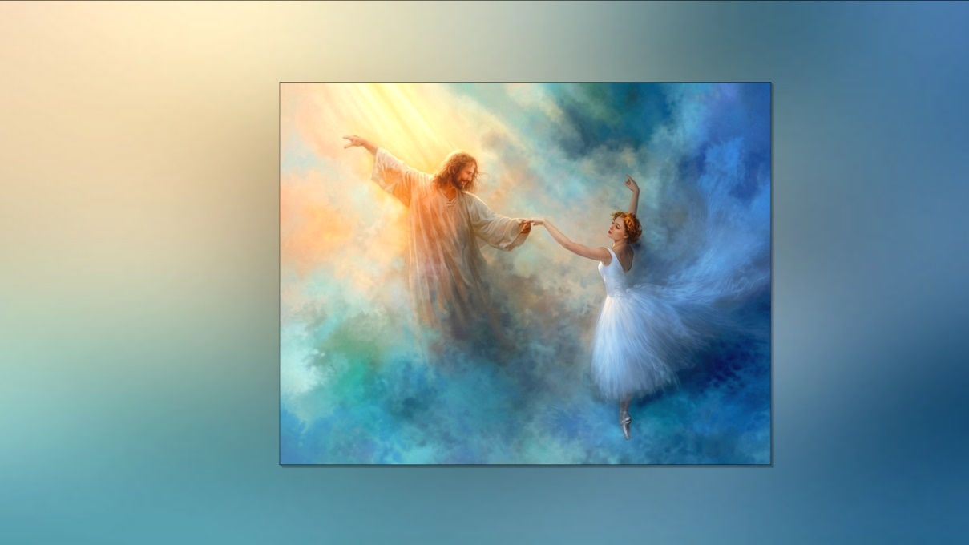

Beloved heart dwellers, may the Lord's peace reign in your hearts today and every day. As tensions increase in this world, meditate more and more about His faithfulness. He has been faithful to care for you all your life. He shall be faithful until the very end. Trust in Him. He is dedicated to your welfare, spirit, soul, and body, as well as those who you love. Family, please pray for me and for our team as well to receive more heaven messages.

As a matter of fact, several of our brothers and sisters are now posting their own heart dwellers videos, and it's very exciting to see them carrying on and growing into this beautiful charism. They spend many hours in prayer, and the Lord speaks to their heart, and then they write everything down and record it for you. So it's very beautiful that the souls who have joined here on the mountain have grown into their prophetic ministries, and that's really what we're all about. We want the souls who deeply love the Lord and are not attached to money or things, but only want to grow in intimacy with Him and to share the beautiful encounters and conversations that He has with them. So now half of the community has their own channel, and it appeals
to different age groups, plus people out in the world, Africa, Russia, France, Germany.

There are heart dwellers messages all over the world, and it's very exciting. Our heart is to prepare people to draw into the intimacy with the Lord and allow Him to use them any way He chooses, and it's so exciting to see them conquering the things that stood in the way of their prophetic calling. That's really what we're all about up here. We are so hated by covens around the world. The most threatening thing in the world to them are Christians who hear directly from the Lord. I have to wait every day upon the Lord to renew my strength and the strength of the brothers and sisters on the mountain because we are hit so hard. He calls us to worship with Him, and when we're worshiping, many times He comes and takes our hand and draws us to the dance
floor. He shows us the garments we're wearing, which are totally His choice. There's such a sweet intimacy as we rest our head upon His heart, and He dances with us. I want this for all of you.

Saturate yourself in worship, my dear ones, and you will grow into this. He is with you all the time. It's a matter of opening your spiritual eyes, not being afraid, but trusting that He loves you and that He wants you to see Him. Okay, so moving on. After a long absence from the Lord because of warfare and also trying to launch a street ministry, I finally found myself dancing with Him, and both of us had our wedding apparel on. I always pray over the playlist and ask Holy Spirit to choose the songs He wants me to worship with. This was a slow dance. Jesus was so thrilled when my eyes opened and I saw His face. Then I knew how much He loved me in spite of my wandering and distractions. It was a tender, special time and my heart just melted. Of course, He was glad to see me with all my bumps and bruises because He loves me and sweeps away all the condemnation. And this is true for you as well.

The enemy spends all his time accusing and condemning. When you get in the Lord's presence, He sweeps all of those lies away. And if there's any truth to them, all you have to do is tell them you're sorry. Ask Him to forgive you and go on. And His heart is to validate you, it's to strengthen you, affirm you. That's His heart. His heart is not to chastise you. He understands your weaknesses and He aches to help us when we get caught up in them.

He and His servants spend almost every moment of their existence condemning Christians and causing them to hide from Jesus. And this truly hurts Him. This is why Satan does it. He also knows that if they withdraw, they will be easy prey because of a wounded spirit. So we danced together blissfully for the longest time. And then I thought to myself, maybe he wants to go to war. No sooner had I thought that when Nikos Pelasius' song played and the scene transformed into a battlefield with huge white war horses and angels and soldiers brandishing swords. They were coming together in formation to obliterate the enemy who stood far off from their black steeds. But just then the music changed to charging battle music.

I was on the Lord's horse behind Him in white battle attire and armor as the music became more and more dramatic. Jesus led His army forth with power, galloping full stride towards the enemy. And soon I began to see a battlefield full of slain enemies lying on the ground.

Then when the music changed, I found myself with Jesus off the horse. And very sweet music by Freddie and Rebecca Haylard played in the background. I snuggled under Jesus' chin, just tucked away in a very satisfying, dreamy state of total trust and relaxation. The next song was about abandoning ourselves to Him, His agenda. And I felt it had to land on everyone.

What a beautiful sense of security and peace washed over my soul. I clung to Jesus with all my heart, remembering that He fights our battles and He will slay the enemy of our souls. Amen.

Now, dear family, I just want to give you a couple of heads ups here. For those of you who are contributing to our support, please make your checks out to heart dwellers. Two words, no inc after it. A bank is very fussy. Okay. And also, we want to reach more souls to warn them. So please, like the videos and stay subscribed. It makes a world of difference. Thank you. We want to prepare as many souls as we can for what is coming. You also are in our prayers, dear ones. Thank you so much for staying with us and looking after us with your prayers. The Lord bless you with a beautiful encounter.

Dancing with Him. Amen.

